**EXPERIMENT 3**

1. Takes a command line argument and reports on whether it is a directory or a file.

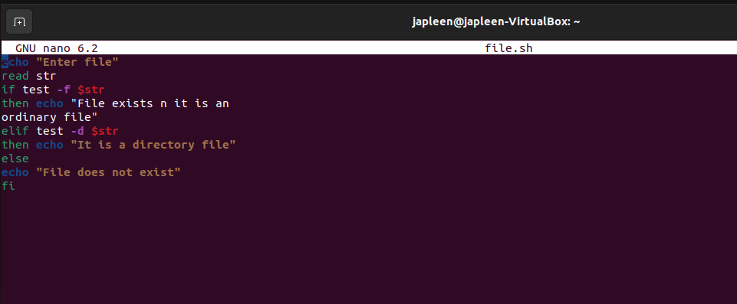

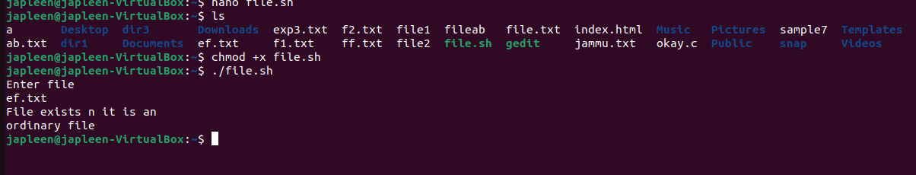

1. Takes the file names as arguments and convert all of them to uppercase.

